PHENIKAA UNIVERSITY
PHENIKAA SCHOOL OF COMPUTING
⸎⸎⸎⸎⸎


LAB REPORT – LAB 1: REQUIREMENTS ANALYSIS & MODELING
Topic: Building a Web-Based Library Management System
Team : Group 1
Student : Nguyễn Đăng Hiếu – 23010049
Nguyễn Trường Sơn – 23010313
Đỗ Hữu Đại 23010825
Bùi Đắc Hợp 23012022
Instructors : Vũ Quang Dũng
Class : Software Architecture(N01)

Hanoi,December 5, 2025

2. Abstract / Summary
The Library Management System (LMS) project aims to digitalize and streamline core library operations, including book management, user management, and the borrowing–returning workflow. This Lab focuses on requirements elicitation and modeling. Functional, Non-Functional, and Architecturally Significant Requirements (ASRs) are documented in a structured format aligned with the Lab 1 specification in the sample report
.
A UML Use Case Diagram is developed to model system boundaries, primary actors (Reader, Librarian, Admin), and essential behavioral relationships. These foundational requirements define the project scope and guide architectural decisions in subsequent labs, particularly the Layered Architecture design in Lab 2.

3. Lab Specific Section: I. Requirements Elicitation & Modeling
This section presents the deliverables for Lab 1.

3.1 Software Requirements Specifications (SRS)
The tables below document the elicited requirements that shape the LMS design.

3.1.1 Functional Requirements (FRs)
ID | Description | Priority
FR-01 | The system must allow a Reader to search for books using keywords, authors, and categories. | High
FR-02 | The system must allow a Reader to borrow available books and view borrowing status. | Critical
FR-03 | The system must support book return processing, including due-date validation and overdue fee calculation. | High
FR-04 | The system must allow a Librarian to perform CRUD (Create, Read, Update, Delete) operations on book records. | High
FR-05 | The system must allow an Admin to manage Librarian accounts and system configurations. | Medium
FR-06 | The system must allow Readers to write and submit book reviews. | Medium

3.1.2 Non-Functional Requirements (NFRs)
ID | Attribute | Description | Impact
NFR-01 | Performance (Latency) | The system must return search results within 2.0 seconds for 90% of queries under normal load. | High
NFR-02 | Security (Integrity) | All user data, including passwords, must be transmitted and stored using encryption (e.g., HTTPS, AES-256). | Critical
NFR-03 | Reliability (Availability) | The system must maintain at least 99.5% uptime during operational hours. | Critical
NFR-04 | Usability | The interface must be accessible, intuitive, and optimized for mobile devices. | Medium

3.1.3 Architecturally Significant Requirements (ASRs)

ASR ID | Quality Attribute | Requirement Statement | Architectural Rationale
ASR-1 | Scalability | The system must support an increase from 100 to 2,000 concurrent student users during peak academic periods (e.g., start of semester). | This requirement challenges a monolithic design and supports adopting a layered or componentized architecture with scalable deployment.
ASR-2 | Security | All access to administrative functions (FR-04 and FR-05) must be restricted to authenticated and authorized Librarian/Admin users via secure token validation. | Necessitates a dedicated security module integrated at the Business Logic Layer to enforce strict access control.
ASR-3 | Modifiability | Integrating new features such as e-book readers or QR-code scanning must not require changes to core Borrowing or User Management components. | Reinforces Separation of Concerns and encourages a layered architecture where subsystems remain isolated.

3.2 Modeling Artifact: UML Use Case Diagram

3.2.1. Main Actors
- User (Reader)
- Librarian (Library Staff)
- Administrator (Admin)
- System (supporting actor: processing, sending notifications)

Use Cases

• User (Reader)
- Register / Login
- Search for books
- View book list and book details
- Borrow books
- Return books
- Renew borrowed books
- Write reviews / comments
- Register for membership

• Librarian
- Manage books (add, update, delete)
- Manage users
- Manage borrowing–returning records
- Check book status
- View statistical reports (most borrowed books, inventory status, users with violations)

• Administrator (Admin)
- Manage librarian accounts (create/update/delete librarian accounts)
- Manage system settings

Actor – Use Case Relationship
Actor | Use Cases
User (Reader) | Register/Login, Search books, View details, Borrow books, Return books, Renew books, Write reviews
Librarian | Manage books, Manage users, Manage borrowing–returning transactions
Administrator | Manage librarians, Manage system

3.2.2. Use Case Diagram
- Admin ↔ (View statistical reports, Manage librarians, Manage the system)
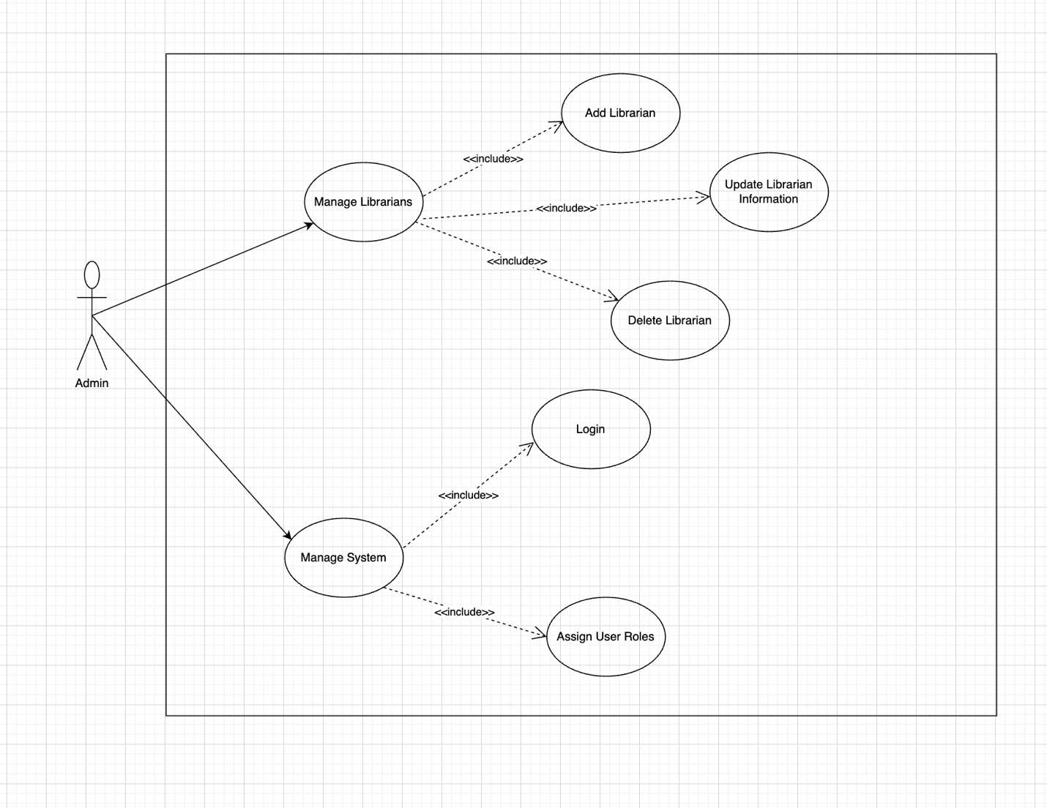
User ↔ (Register/Login, Search for books, View details, Borrow books, Return books, Renew books, Write reviews, Register for membership) 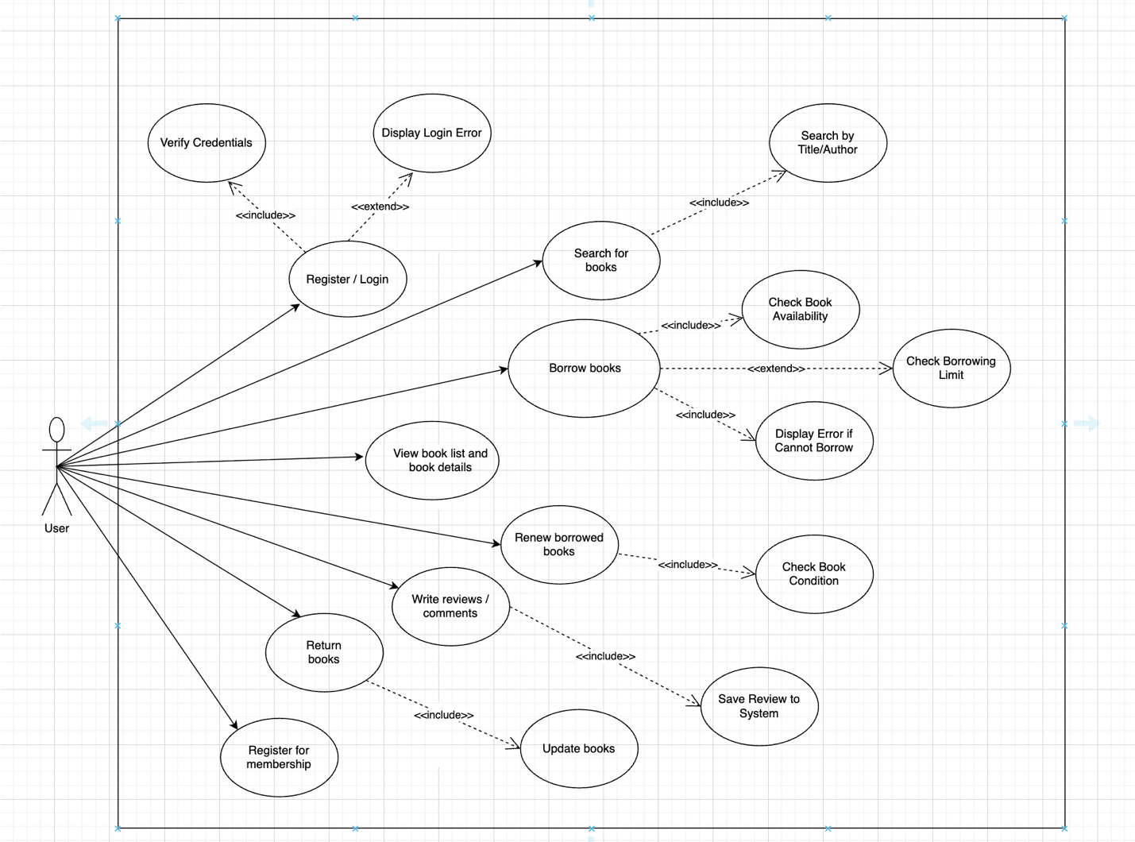

Librarian ↔ (Manage books, Manage users, Manage borrowing–returning records, Check book status, View statistics, Manage digital books)
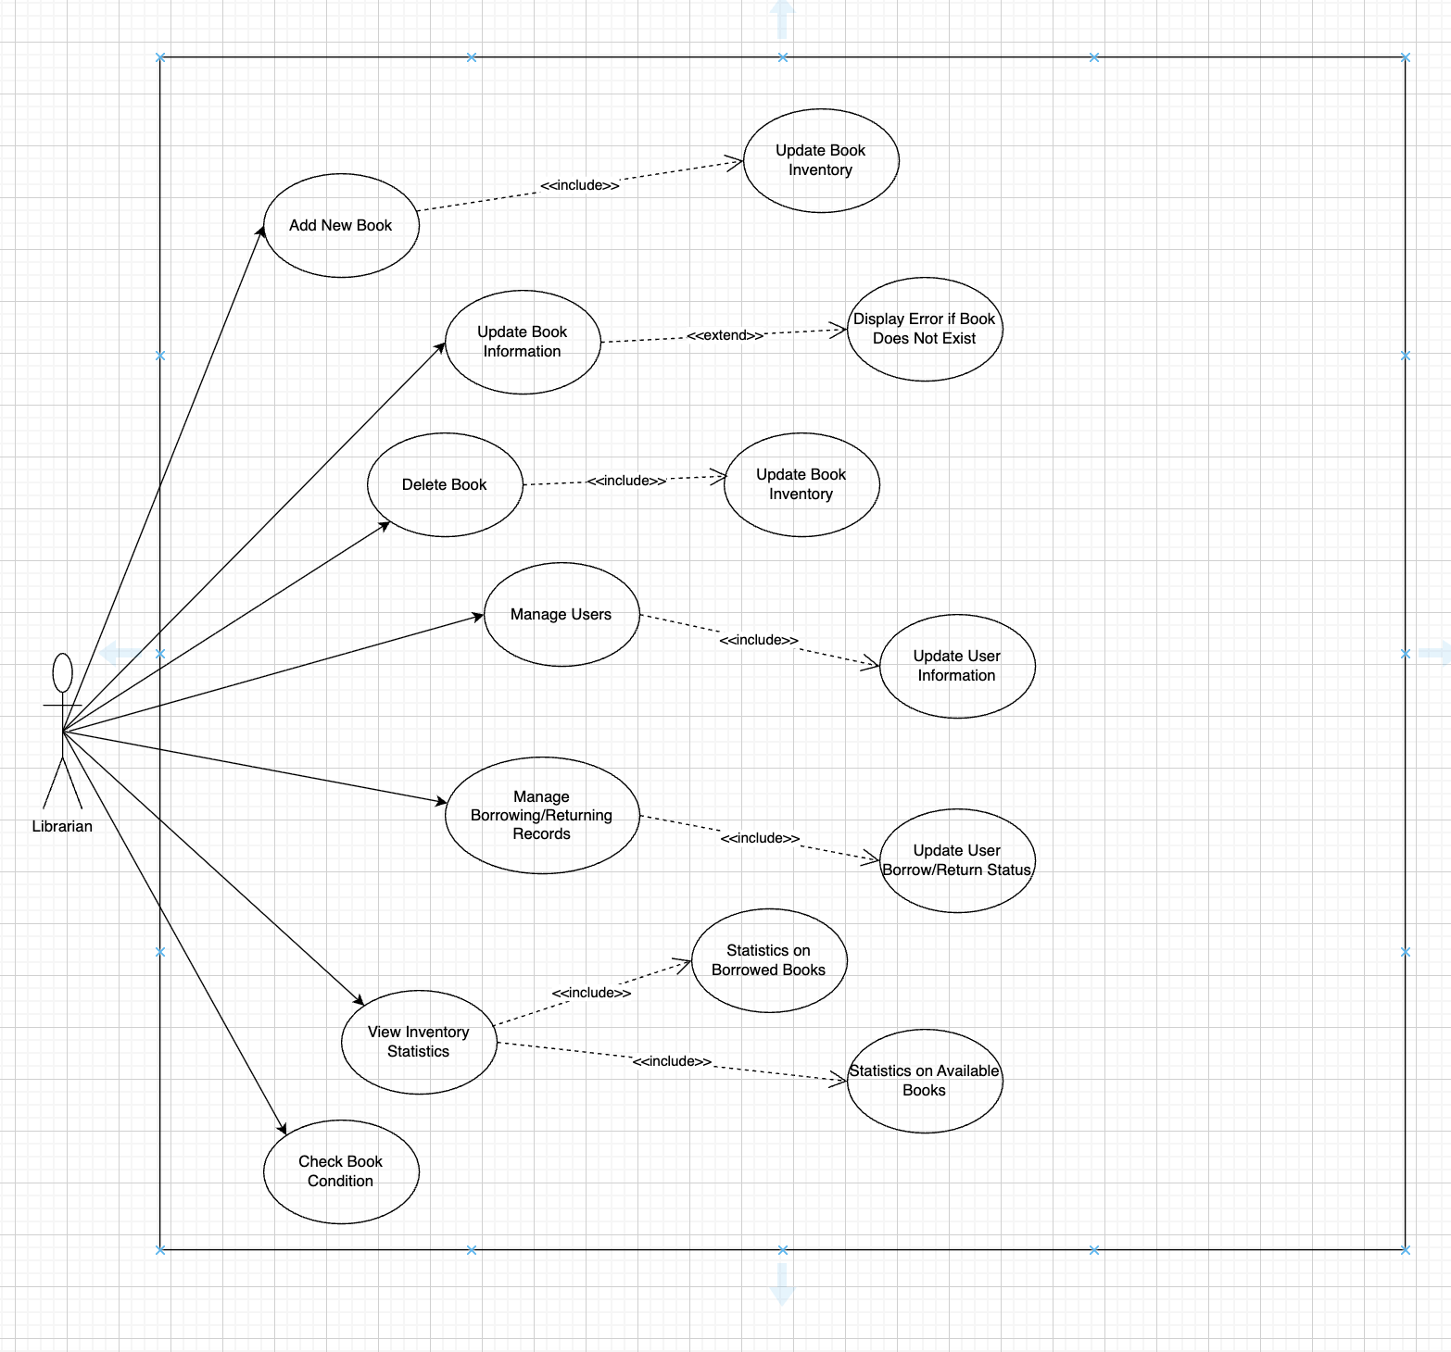

4. Architectural Design (Note: Problem Analysis for Next Lab)
The elicited requirements directly influence the architectural challenge in Lab 2.

4.1 Problem Statement
The architectural problem is to design a system that satisfies core LMS requirements while maintaining strict separation of concerns, security enforcement, and modifiability. A Layered Architecture is selected as the initial structural approach to address ASRs identified in Lab 1.

4.2 Impact of ASRs on Layered Architecture
- ASR-3 (Modifiability) → Layered Structure
Modifiability demands independent components. The four standard layers—Presentation, Business Logic, Persistence, Data—ensure:
  - UI modifications do not affect business logic.
  - Database changes do not impact services, provided interfaces remain stable.
- ASR-2 (Security) → Business Logic Layer
All authorization checks for Librarian/Admin actions must be enforced in the Business Logic Layer.
This ensures consistent security whether requests come from the UI or automated scripts.
These architectural considerations will guide Lab 2, where layers and component interfaces are defined in detail.

5. Conclusion & Reflection
The requirements elicitation phase for the Library Management System successfully established the system’s scope. Functional, Non-Functional, and Architecturally Significant Requirements were collected in structured formats, mirroring the example report
.
The UML Use Case Diagram captures essential user interactions and critical workflows.
ASRs related to Scalability, Security, and Modifiability strongly motivate adopting a layered architecture in the next lab.
These foundations ensure that subsequent design and implementation can be carried out with clarity, sustainability, and architectural alignment.

